***“Towards Global Technical Excellence”***

A Project Report on

**"Health Prediction and Doctor Allocation"**

**TABLE OF CONTENTS**

|  |  |  |
| --- | --- | --- |
| **Chapter No.** | **Title** | **Page No.** |
|  | **List of Abbreviations** | i |
|  | **List of Figures** | ii |
| 1 | **INTRODUCTION** | 1 |
| 2 | **LITERATURE SURVEY** | 4 |
| 3 | **TECHNOLOGIES USED** | 6 |
|  | 3.1 Python  3.1.1 Django web framework  3.1.2 Pandas library  3.2 MySQL database | 11  11  12  12 |
|  | 3.3 jQuery  3.4 Ajax | 13  13 |
|  | 3.4.1 JSON  3.5 Web technologies | 14  14 |
|  | 3.5.1 HTML ad CSS | 14 |
| 4  5 | 3.2.3 Bootstrap  **SYSTEM DESIGN**  **IMPLEMENTATION**  5.1 Home Page  5.2 Login/Register page  5.3 Change password Activity  **5.4 Patient**  5.4.1 Home Page  5.4.2 My appointment Activity  5.4.3 Activity log  **5.5 Doctor**  5.5.1 Home Page  5.5.2 Profile Page  5.5.3 Add Disease Activity  5.5.4 Activity Log  **5.6 Admin** | 15  35  35  45  453  54  423  43  4325  43  45  764  54  647  56  754 |
| 6 | **CONCLUSION** | 20 |
|  | 6.1 Conclusion | 20 |
|  | 6.2 Future Scope | 20 |
| 7 | **REFERENCES** | 21 |

**I. List of Abbreviations:**

|  |  |  |
| --- | --- | --- |
| Sr. No. | Abbreviations | Illustrations |
| 1 | CSV | Comma Separated File |
| 2 | AJAX | Asynchronous JavaScript and XML |
| 3 | JSON | JavaScript Object Notation |
| 4 | UI | User Interface |

**II. List of Figures:**

|  |  |  |
| --- | --- | --- |
| Sr. No. | Figure Name | Page No. |
| 1 | Home Page | 12 |
| 2 | User Login Form | 13 |
| 3 | User Registration Form | 14 |
| 4 | Admin Login Form | 15 |
| 5 | Change Password Activity | 16 |
| 6 | Forgot Password Activity | 17 |
| 7 | Patient Home Page A | 17 |
| 8 | Patient Home Page B | 18 |
| 9 | Patient Home Page C |  |
| 10 | My Appointment Activity |  |
| 11 | Patient Activity Log |  |
| 12 | Doctor Home Page |  |
| 13 | Doctor Profile Page |  |
| 14 | Add Disease Activity |  |
| 15 | Doctor Activity Log |  |
| 16 | Admin Home Page |  |

**1. INTRODUCTION**

**Health Prediction** is a system which helps a user to find their health status. It might have happened so many times that you or someone yours need doctors to help immediately, but they are not available due to some reason. The Health Prediction system is an end user support and online consultation project.

Here we propose a system that allows users to get instant guidance on their health issues through an intelligent health care system online. The system is fed with various symptoms and the disease/illness associated with those systems. The system allows a user to share their symptoms and issues. It then processes the user’s symptoms to check for various illnesses that could be associated with it. Here we use some intelligent data mining techniques to guess the most accurate illness that could be associated with a patient’s symptoms.

In doctor module when doctor login to the system doctor can view his patient details and the report of that patient. A doctor can view details about the patient search what patient searched for according to their prediction. A doctor can view his personal details.

Admin can add new disease details by specifying the type and symptoms of the disease into the database. Based on the name of the disease and symptom the data mining algorithm works. Admin can view various disease and symptoms stored in the database. This system will provide proper guidance when the user specifies the symptoms of his illness.

**2. LITERATURE SURVEY**

The literature review reveals that Nowadays, the prediction of various diseases by using an automated system is a significant alternative for medical decision by doctors. Such automated systems are able to assist the patients, hospital enquiry personals and doctors to acquire the correct information about the disease. Machine learning approaches are used intensively to predict diseases such as heart disease, lung cancer, liver diseases etc. In this project, we focus on the various machine learning approaches used in disease predicting systems.

Proposed study of huge datasets from various angles and obtaining gist of useful information. Aims to calculate various methods of data mining in applications to develop decisions and also to provide a detailed discussion about medical. These methods are useful in detecting diseases and providing proper remedy for the same. Data mining techniques can improve various angles of clinical predictions. The data mining comprises of analysis of large data from various perspectives and obtaining summary of useful information. The information can be transferred into knowledge regarding future trends and history. Medical data mining has been a popular data mining topic of late.

**3. TECHNOLOGIES USED**

Here is a brief description of different technologies used in this system.

**3.1 Python**

**Python** is an interpreted, high-level, general-purpose programming language. Created by **Guido van Rossum** and first released in **1991**, Python has a design philosophy that emphasizes code readability, notably using significant whitespace. It provides constructs that enable clear programming on both small and large scales.

Python features a dynamic type system and automatic memory management. It supports multiple programming paradigms, including object-oriented, imperative, functional and procedural. It also has a comprehensive standard library. Its standard library is made up of many functions that come with Python when it is installed. On the Internet there are many other libraries available that make it possible for the Python language to do more things. These libraries make it a powerful language; it can do many different things.

**3.1.1 Django web framework**

**Django** is a high-level Python Web framework that encourages rapid development and clean, pragmatic design. Built by experienced developers, it takes care of much of the hassle of Web development, so you can focus on writing your app without needing to reinvent the wheel. It’s free and open source

Django includes dozens of extras you can use to handle common Web development tasks. Django takes care of user authentication, content administration, site maps, RSS feeds, and many more tasks — right out of the box. Django takes security seriously and helps developers avoid many common security mistakes, such as SQL injection, cross-site scripting, cross-site request forgery and clickjacking. Its user authentication system provides a secure way to manage user accounts and passwords. Some of the busiest sites on the planet use Django’s ability to quickly and flexibly scale to meet the heaviest traffic demands. Companies, organizations and governments have used Django to build all sorts of things — from content management systems to social networks to scientific computing platforms.

**3.1.2 Pandas library**

**Pandas** is an open source, BSD-licensed library providing high-performance, easy-to-use data structures and data analysis tools for the Python programming language. pandas is a NumFOCUS sponsored project. This will help ensure the success of development of pandas as a world-class open-source project, and makes it possible to donate to the project

Python has long been great for data munging and preparation, but less so for data analysis and modeling. pandas helps fill this gap, enabling you to carry out your entire data analysis workflow in Python without having to switch to a more domain specific language like R. Combined with the excellent IPython toolkit and other libraries, the environment for doing data analysis in Python excels in performance, productivity, and the ability to collaborate.

Pandas does not implement significant modeling functionality outside of linear and panel regression; for this, look to statsmodels and scikit-learn. More work is still needed to make Python a first class statistical modeling environment, but we are well on our way toward that goal.

**3.2 MySQL Database**

**MySQL** is an open source relational database management system (RDBMS). Its name is a combination of "My", the name of co-founder Michael Widenius's daughter, and "SQL", the abbreviation for Structured Query Language.

MySQL is free and open-source software under the terms of the GNU General Public License, and is also available under a variety of proprietary licenses. MySQL was owned and sponsored by the Swedish company MySQL AB, which was bought by Sun Microsystems (now Oracle Corporation). In 2010, when Oracle acquired Sun, Widenius forked the open-source MySQL project to create MariaDB.

MySQL is a component of the LAMP web application software stack which is an acronym for Linux, Apache, MySQL, Perl/PHP/Python. MySQL is used by many database-driven web applications, including Drupal, Joomla, phpBB, and WordPress. MySQL is also used by many popular websites, including Google (though not for searches), Facebook, Twitter, Flickr, and YouTube.

**3.3 jQuery**

**jQuery** is a fast, small, and feature-rich JavaScript library. It makes things like HTML document traversal and manipulation, event handling, animation, and Ajax much simpler with an easy-to-use API that works across a multitude of browsers. With a combination of versatility and extensibility, jQuery has changed the way that millions of people write JavaScript.

jQuery's syntax is designed to make it easier to navigate a document, select DOM elements, create animations, handle events, and develop Ajax applications. jQuery also provides capabilities for developers to create plug-ins on top of the JavaScript library. This enables developers to create abstractions for low-level interaction and animation, advanced effects and high-level, themeable widgets. The modular approach to the jQuery library allows the creation of powerful dynamic web pages and Web applications.

**3.4 Ajax**

**AJAX** stands for **A**synchronous **Ja**vaScript and **X**ML. AJAX is a new technique for creating better, faster, and more interactive web applications with the help of XML, HTML, CSS, and Java Script.

**Ajax** is a set of web development techniques using many web technologies on the client side to create asynchronous web applications. With Ajax, web applications can send and retrieve data from a server asynchronously (in the background) without interfering with the display and behavior of the existing page. By decoupling the data interchange layer from the presentation layer, Ajax allows web pages and, by extension, web applications, to change content dynamically without the need to reload the entire page. In practice, modern implementations commonly utilize JSON instead of XML.

**3.4.1 JSON**

**JavaScript Object Notation** (**JSON**) is an open-standard file format that uses human-readable text to transmit data objects consisting of attribute–value pairs and array data typesIt is a very common data format used for asynchronous browser–server communication, including as a replacement for XML in some AJAX-style systems.

JSON is a language-independent data format. It was derived from JavaScript, but as of 2017 many programming languages include code to generate and parse JSON-format data. The official Internet media type for JSON is **application/json**. JSON filenames use the extension **.json**.

**3.5 Web technologies**

**Web technology** is a methods by which computers communicate with each other through the use of markup languages and multimedia packages. In the past few decades, web technology has undergone a dramatic transition, from a few marked up web pages to the ability to do very specific work on a network without interruption.

**3.5.1 HTML and CSS**

**Hypertext Markup Language** (**HTML**) is the standard markup language for creating web pages and web applications. With Cascading Style Sheets (CSS) and JavaScript, it forms a triad of cornerstone technologies for the World Wide Web. Web browsers receive HTML documents from a web server or from local storage and render the documents into multimedia web pages. HTML describes the structure of a web page semantically and originally included cues for the appearance of the document.

**Cascading Style Sheets** (**CSS**) is a style sheet language used for describing the presentation of a document written in a markup language like HTML. CSS is a cornerstone technology of the World Wide Web, alongside HTML and JavaScript. CSS is designed to enable the separation of presentation and content, including layout, colors, and fonts. This separation can improve content accessibility, provide more flexibility and control in the specification of presentation characteristics, enable multiple web pages to share formatting by specifying the relevant CSS in a separate **.css** file, and reduce complexity and repetition in the structural content.

**3.5.2 Bootstrap**

**Bootstrap** is a free and open-source front-end Web framework. It contains HTML and CSS-based design templates for typography, forms, buttons, navigation and other interface components, as well as optional JavaScript extensions. Unlike many earlier web frameworks, it concerns itself with front-end development only.

Bootstrap is a web framework that focuses on simplifying the development of informative web pages (as opposed to web apps). The primary purpose of adding it to a web project is to apply Bootstrap's choices of color, size, font and layout to that project. As such, the primary factor is whether the developers in charge find those choices to their liking. Once added to a project, Bootstrap provides basic style definitions for all HTML elements. The end result is a uniform appearance for prose, tables and form elements across web browsers. In addition, developers can take advantage of CSS classes defined in Bootstrap to further customize the appearance of their contents. For example, Bootstrap has provisioned for light- and dark-colored tables, page headings, more prominent pull quotes, and text with a highlight.

**5. IMPLEMENTATION**

Here, the details about each page in the website and different sections are explained.

**5.1 Home Page**

The home page is the main web page which set as the default or start-up page of the project contains various links refer to internal sections of the project.

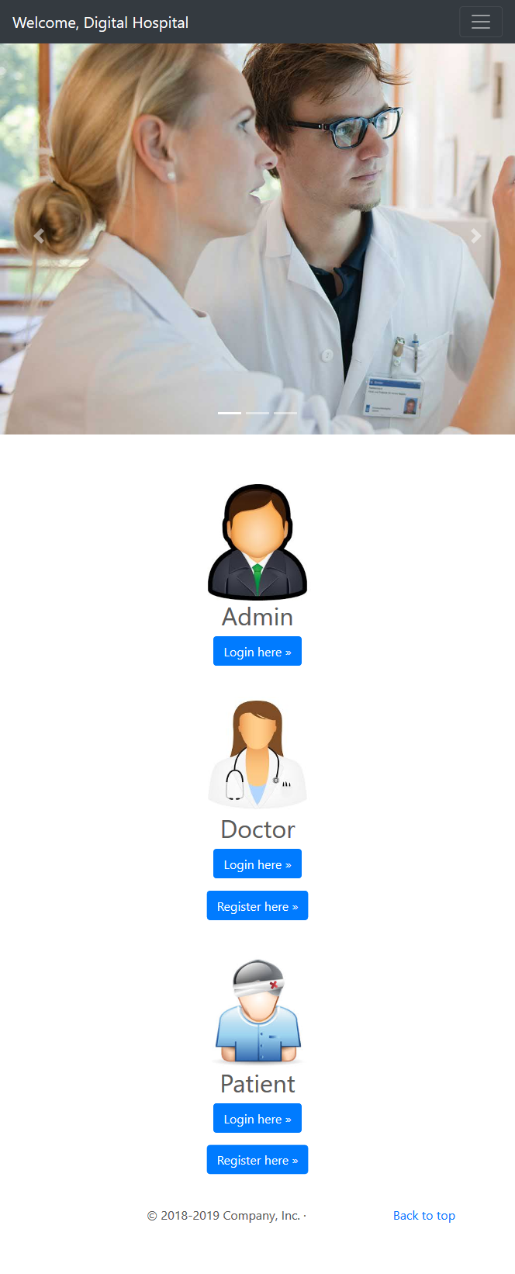

Fig 5.1 Home Page

**5.2 Login/Register Page**

The login page provides functionalities for creating a new account with the app or logging in with registered email-ids. It has user validation and authentication facilities, more than one user with the same email-id are not allowed to register. Also the password length should be more than six characters. On clicking on the register button the user is directed to the homepage.

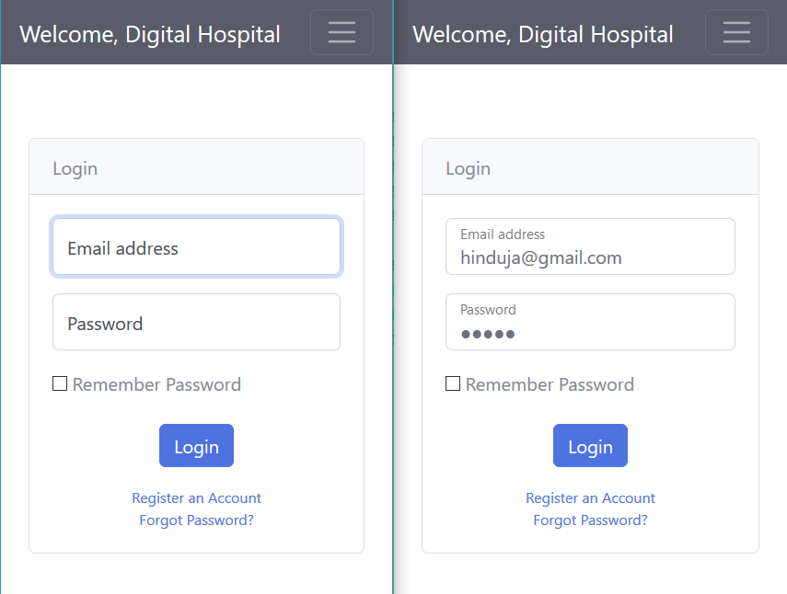

Fig 5.2 User Login Form

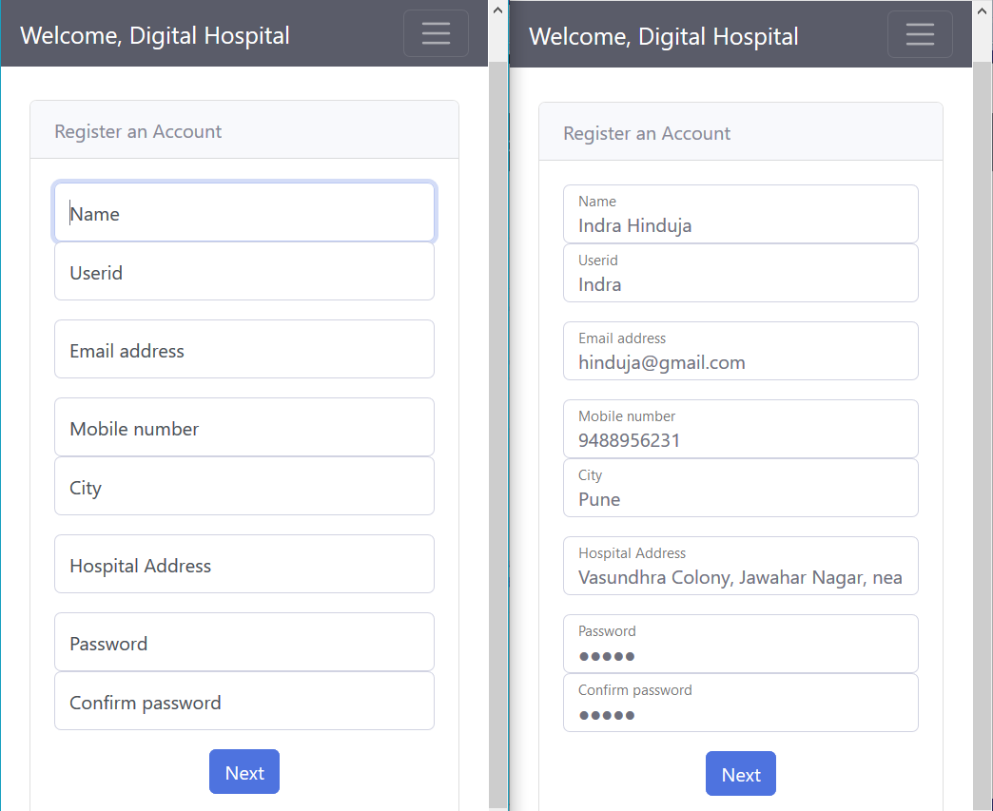

Fig 5.3 User Registration Form

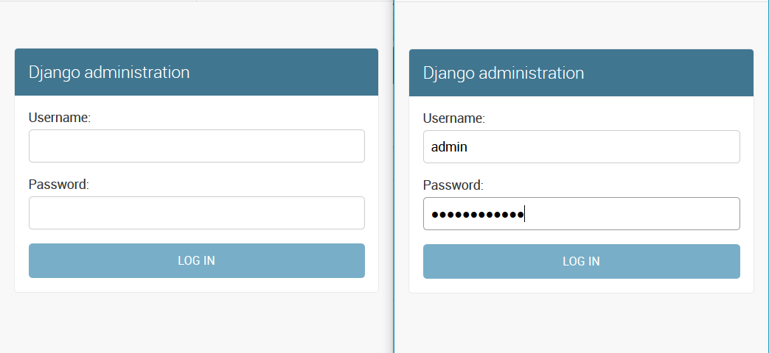

Fig 5.4 Admin Login Form

**5.3 Change Password Activity**

The third activity of this patient system is change password activity. On this page, patient is allowed to change the password. To change the password user required to enter old password, new password, confirm password for confirmation. Then hit the “Change Password” to change the password for next time login session.

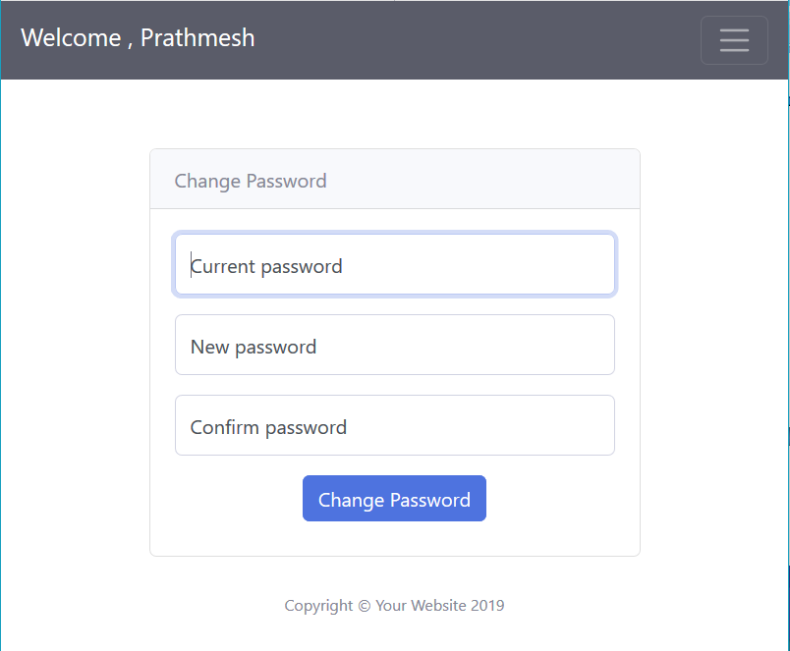

Fig 5.5 Change Password Activity

**5.3 Forgot Password Activity**

The third activity of this patient system is change password activity. On this page, user is allowed to recover the password. To recover the password user required to select security question which is selected while registration and answer of that question.

Provide new password and confirm password for confirmation. Then hit the “Reset Password” to change the password for next time login session.

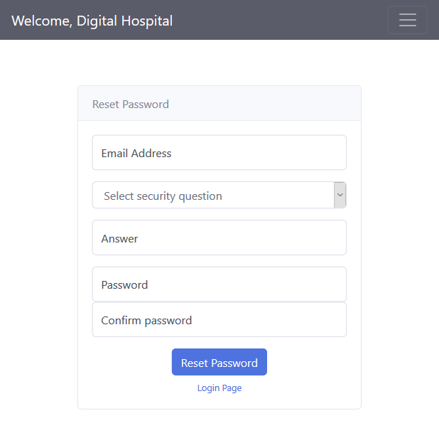

Fig 5.6 Forgot Password Activity

**5.4 Patient**

**5.4.1 Home Page**

The user is welcomed to the home screen. The page provides a dropdown list to select symptoms and search for predicted disease. Also, there is a different facilities option for maintaining appointment history, upcoming appointment information and change password facility. The user can click on any of these links as required and will be directed to the given page. After the disease is predicted then a user can look up for the doctor suggestions by hit the button “These are my symptoms” and also book for the appointment by hit the button “Take Appointment”. Also, a logout button is provided if the user wishes to end the ongoing session.

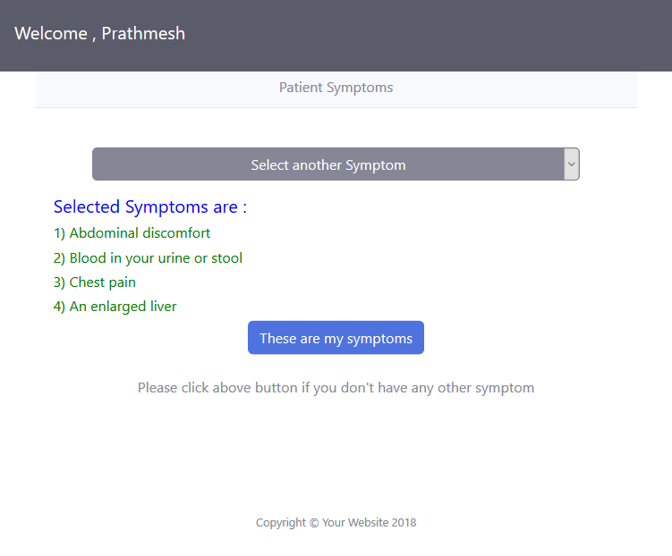

Fig 5.7 : Patient Home Page A

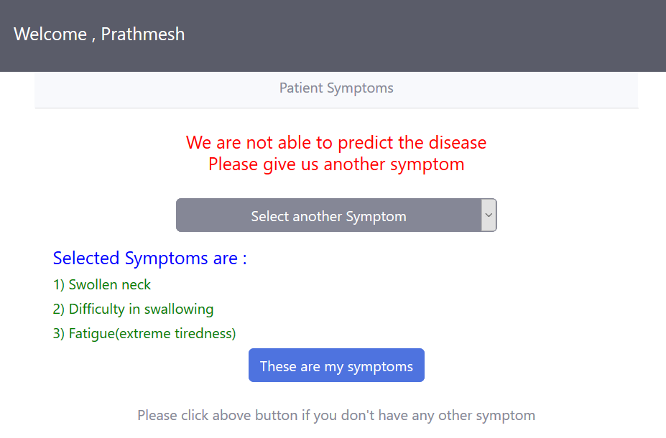

Fig 5.8 : Patient Home Page B

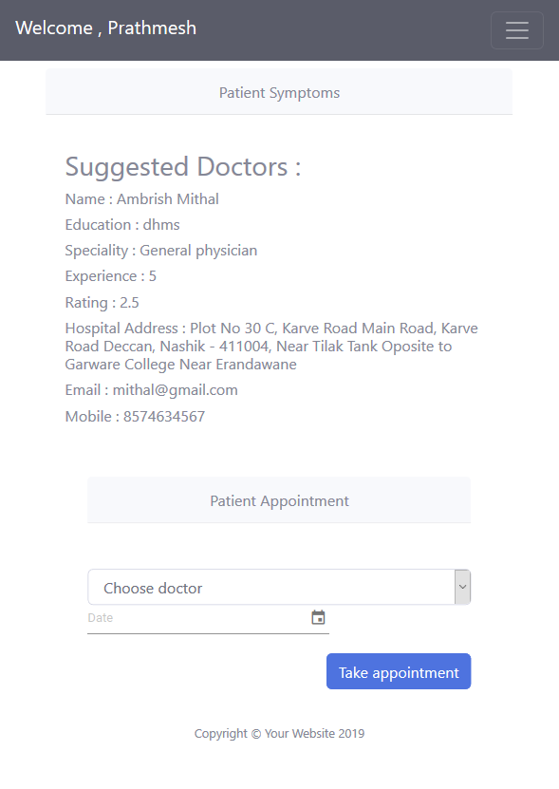

Fig 5.9 : Patient Home Page C

**5.4.2 My Appointment Activity**

The second activity of this patient system is to maintain the record of appointment taken by the user. On this page, the user can also search for the appointment by specifying keywords in the search textbox.

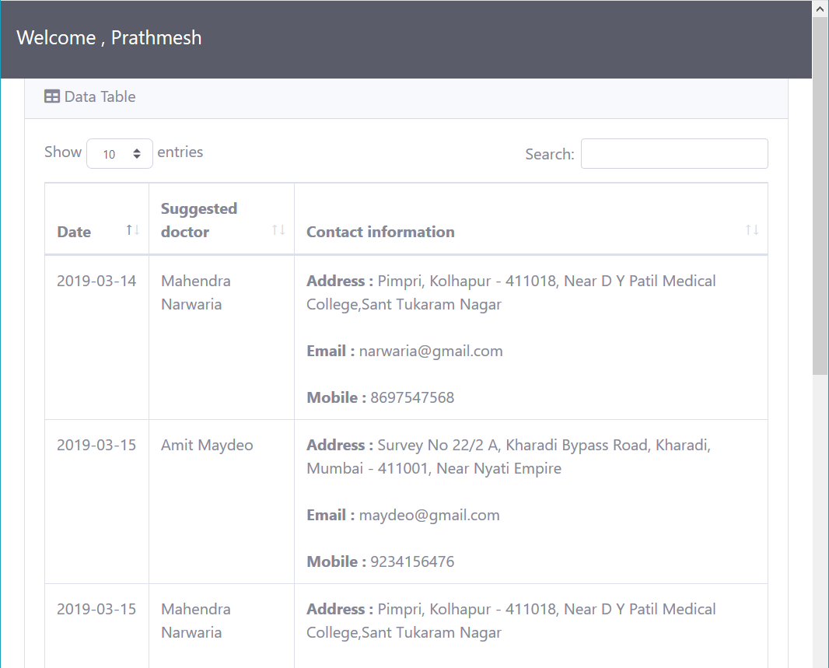

Fig 5.10 : My Appointment Activity

**5.4.3 Activity Log**

`This Project have activity to maintain the record of Search disease for user contains date, suggested disease, selected symptoms, Suggested doctor and doctor contact information including address, email, mobile number and last column is for appointment status i.e. “yes” if doctor is suggested an appointment is taken at particular date or “No” if doctor is suggested an appointment is not taken. There is a search field to enter a keyword for finding a particular record. These details are stored in the patient-user database at the back end and used for future use. 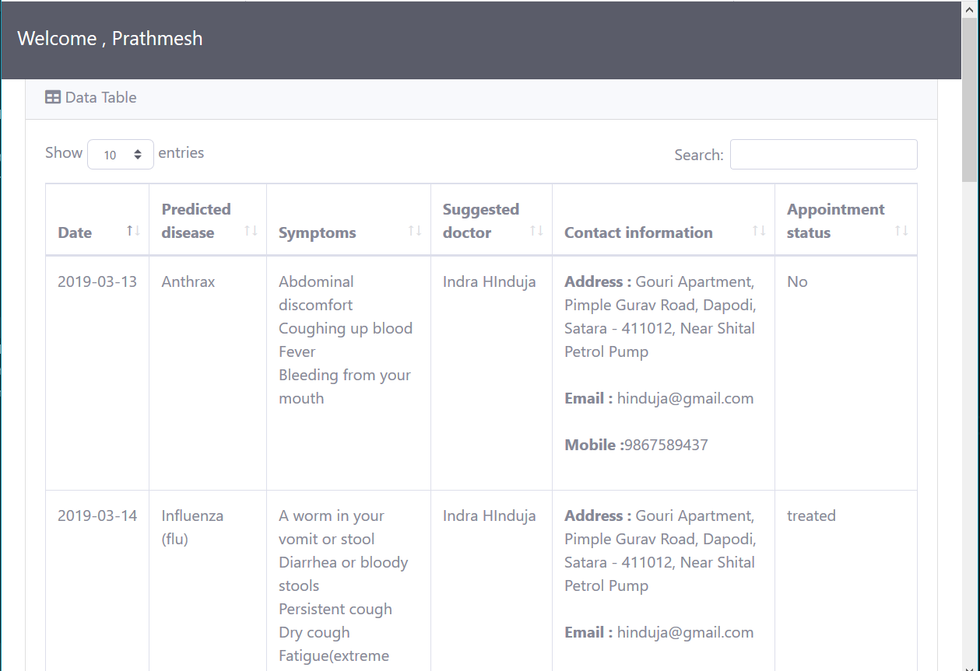

Fig 5.11 : Patient Activity Log

**5.5 Doctor**

**5.5.1 Home Page**

The user is welcomed to the home screen. The page provides a tabular format to show booked appointment for doctor user of the system. This tabular form contains information such as appointment date, patient name, disease, symptoms selected by that patient and treatment status. In treatment status column doctor user has two facilities such as treated and delete. Treated if a doctor treats that particular patient then this link update status in the database and Delete if the doctor wants to cancel the appointment of the patient. Also, there is a different facilities option for maintaining a profile, add new disease with symptoms and change password facility, activity log. The user can click on any of these links as required and will be directed to the given page. Also, a logout button is provided if the user wishes to end the ongoing session.

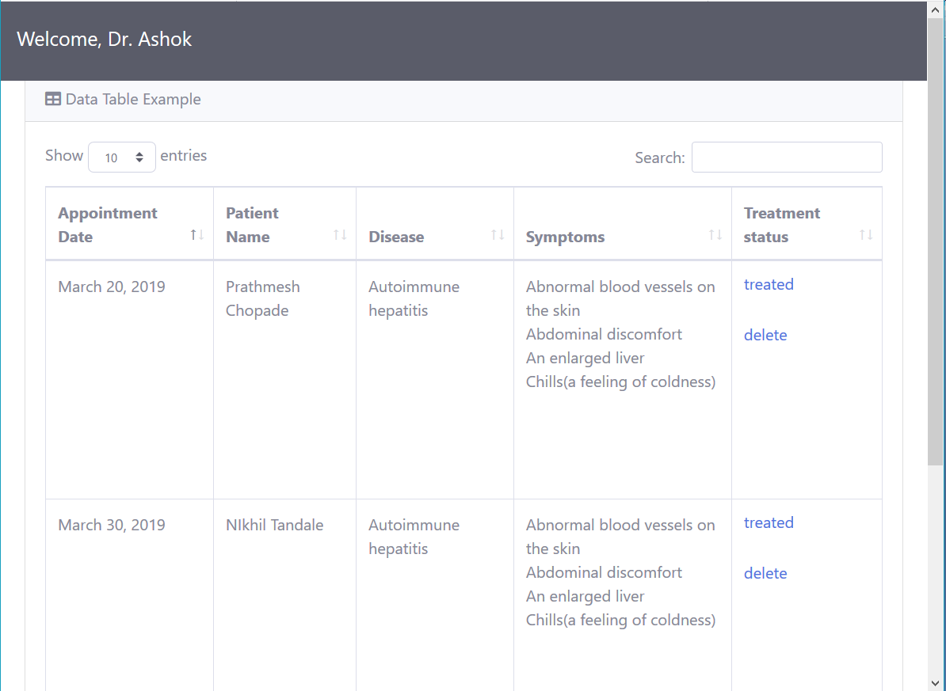

Fig 5.12 : Doctor Home page

**5.5.2 Profile Page**

This user **profile Page** is a visual display of personal data associated with a specific user, or a customized desktop environment. A **profile** refers to the explicit digital representation of a person's identity. A user **profile** can also be considered as the computer representation of a user model. This page contains personal information which is shown to our patient while doctor suggestion and it contains a name, education of doctor, contact information with hospital/clinic address, speciality and rating.

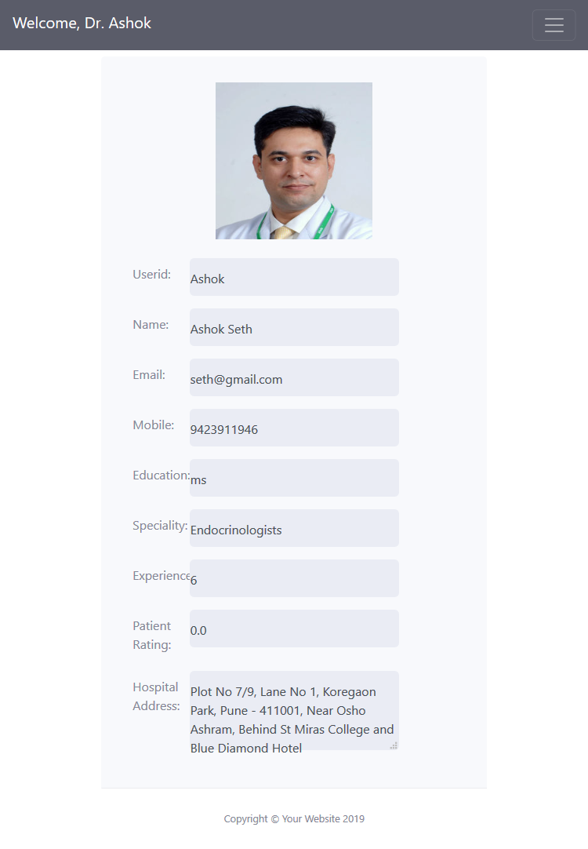 Fig 5.13 : Doctor Profile Page

**5.5.3 Add Disease Activity**

The third activity of this doctor system is to add disease activity. On this page,

A doctor can add new disease and its symptoms as per the new research on diseases. This new information is added to the database at the background of this project and processes for the patient symptoms based disease prediction system. This activity is very important for perfect prediction of the disease because as the symptoms and diseases are clearer to the backend algorithms will work without any conflicts.

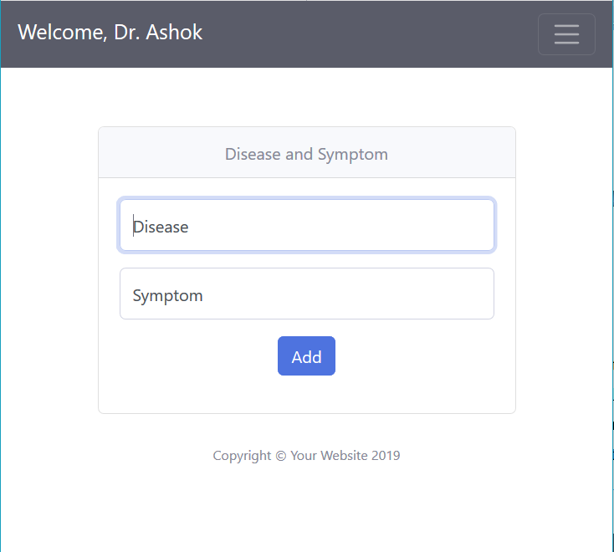

Fig 5.14 : Add Disease Activity

**5.5.4 Activity Log**

The user can maintain the record of Patient treatment date, Patient name, Disease, Symptoms. There is a search field to enter a keyword for finding a particular record. These details are stored in the patient-user database at the back end and used for future use.

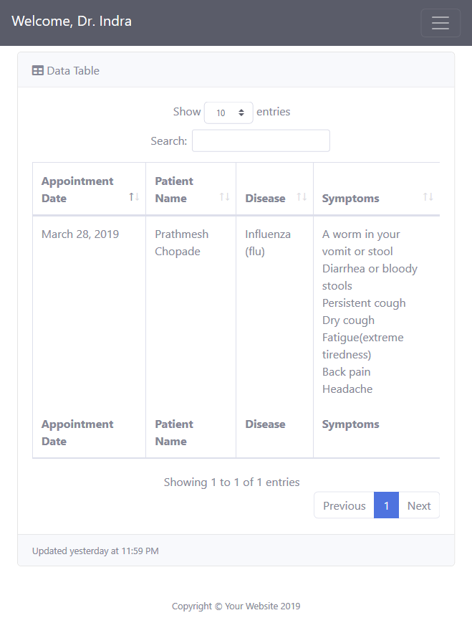

Fig 5.15 : Doctor Activity Log

**5.6 Admin**

This Admin module contains all the record of the backend database. Only the admin is authenticated to this section. This section can edit the record, delete the record, update the record and insert the record, etc all the rights that one admin should have can be performed in this admin section.

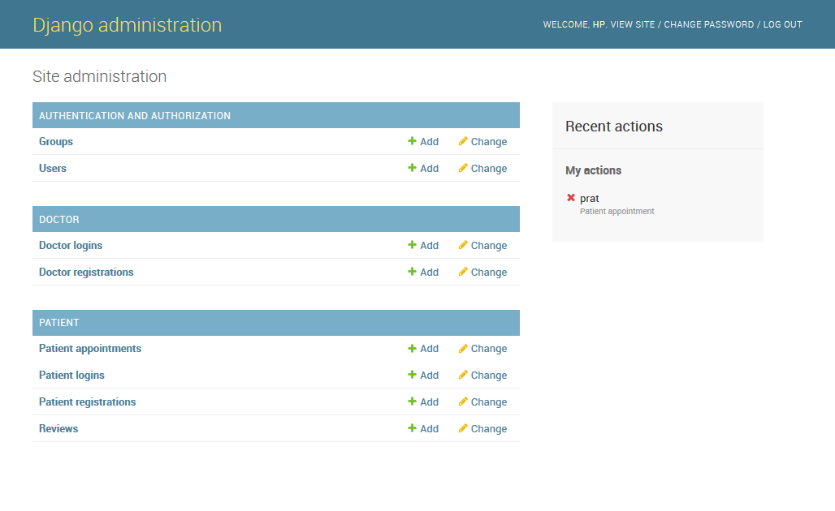

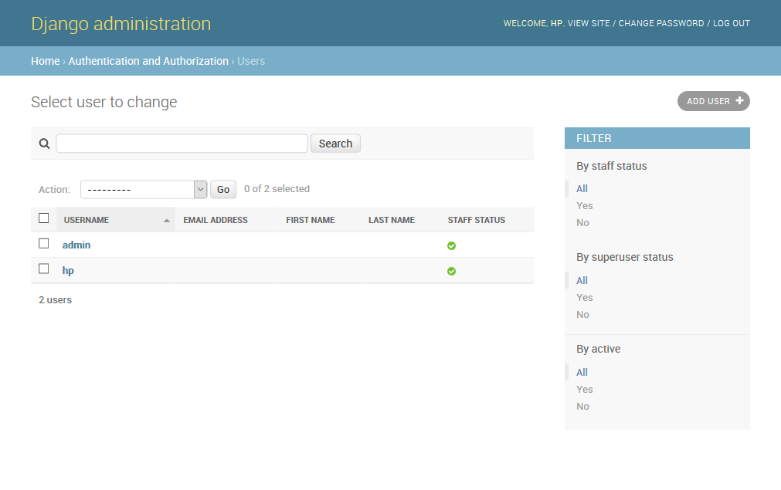Fig 5.16: Admin Home Page

**6. CONCLUSION**

**6.1 Conclusion**

Health care is moving into the home increasingly often and involving a mixture of people, a variety of tasks, and a broad diversity of devices and technologies; it is also occurring in a range of residential environments. From the outset it was clear that the dramatic and evolving change in health care practice and policies presents a broad array of opportunities and problems.

In the proposed system, hidden knowledge will be extracted from the historical data by preparing datasets by applying algorithm. The system should be efficient to predict the diseases and suggestion of medications using machine learning techniques like Classification, Association rule mining. It has very wide range of scope in case of diseases. Further the system can be extended to number diseases existing with proper medications. It can made available with the doctors through live appointment so the end user can freely interact with the doctor in case of emergency

**6.2 Future Scope**

This proposed methodology will work on real historical data, it will provide accurate and efficient results, which will help patients get diagnosis instantly. This system will also guide the users of how to remain healthy and fit using tips provided here. The further enhancements that can be done would be integrating this web application in an Android app. This will be available to users on a mobile basis and its use can be further increased. Also, feature like getting the doctor online on chat so that patients can directly talk to the concerned doctors. The modules doing cancer analysis can be integrated to find how close the person associated with cancer is. This will make this web application predictable in a true sense.

We learned all these technologies for successful completion of this project and implemented them in it.

**7. REFERENCES**

1. http://www.academia.edu/37017033/A_Smart_Health_Prediction_Using_Data_Mining

2. https://www.ijraset.com/fileserve.php?FID=11712

3. https://www.youtube.com/channel/UCsRY-UVUNYi0NW7RwxNLBQA

4. https://www.kaggle.com/datasets

5. https://software.intel.com/en-us/android/articles/installation-instructions-for-intel-hardware-accelerated-execution-manager-windows